**NOBOCAP COMMUNITY COMMUNICATION TOOLKIT**

**FOR CLUSTERS & HUBS**

1. Logo of NoBoCap community (if you need another format, please contact diana@defuturo.lt):

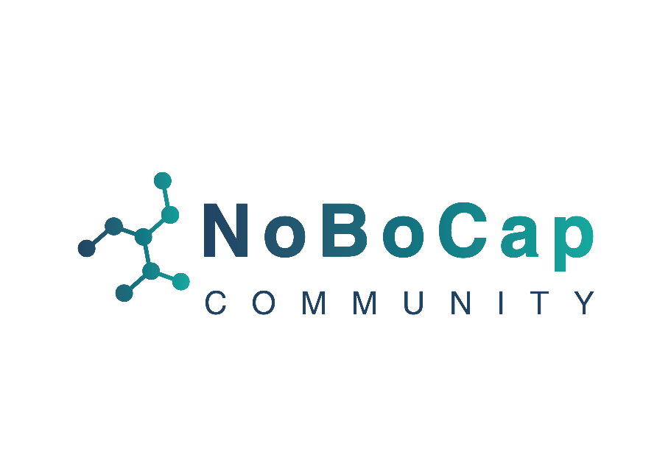

1. Social Media Graphics: Banner for various social media platforms to promote that you are part of NoBoCap community and its activities:

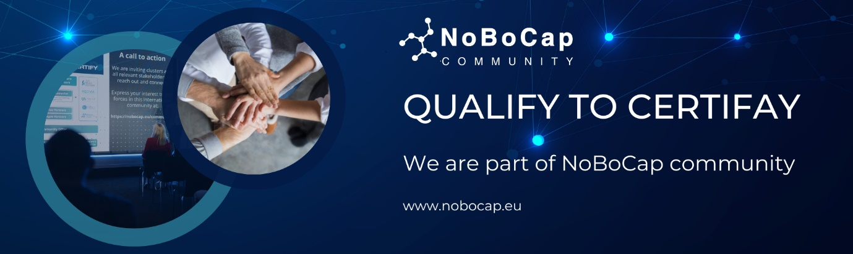

1. Message to use with the banner as an initial email to your members

* to inform your own members about the fact that you are part of NoBoCap Community

Dear Members,

We are happy to announce that [Cluster/Innovation Hub] is now an integral part of the NoBoCap Community – within the Notified Body Increased Capacity (NoBoCap) Project, funded under the wings of the EU4Health Programme (EU4H).

**NoBoCap** is a project to educate and ensure preparedness of Market Operators (MOs) in the application of MDR and IVDR and build out a quality and accessible Notified Bodies and Regulatory ecosystem. Within the project, **NoBoCap Community** is a group of organizations working towards increasing knowledge and preparedness of the EU Regulatory system and access to NBs for innovators and be a player to voice and address EU regulatory challenges.

By joining the NoBoCap Community, we are reinforcing our commitment to fostering innovation and compliance within our network. This affiliation presents numerous opportunities for collaboration, knowledge sharing, and collective growth.

As members of our [Cluster/Innovation Hub], what you can expect as part of our involvement in the NoBoCap Community is:

* Intel on the latest development of EU Regulations and your implication as Innovator in the regulatory ecosystem;
* Connection with other organizations and initiatives across Europe in order to understand and address MDR/IVDR;
* Access to NoBoCap Conferences - Training – Tools;
* Overview of additional resources to help with MDR/IVDR;
* Listed as and recognized as member of the Community;

Your involvement will empower your entity to stay informed, connected, and recognized within the medical device industry.

Best regards,

1. Message to inform your r own members about the events/trainings which will be held under NoBoCap project:

**Informational Email**

to attend NoBoCap Community organized events (webinars, conferences, etc.)

Dear Members,

As part of the NoBoCap Community, we are happy to invite you to an upcoming webinar focused on the NoBoCap Project and [PURPOSE OF EVENT]. This event will take place on [DATE: March 21st] from [TIME: 13:00 to 16:00 (GMT+1)].

Here are the details:

**Event:** [TITLE OF THE EVENT]

**Date:** [DATE AND TIME: March 21, 13:00-16:00 (GMT+1)]

**Agenda:** [INSERT AGENDA]

Notified Body Increased Capacity (NoBoCap) Project aims to educate and ensure the preparedness of Market Operators (MOs) in the application of MDR and IVDR, while also fostering a quality and accessible ecosystem for Notified Bodies and Regulatory compliance.

This webinar presents an excellent opportunity to learn more about the project, engage with the community, and contribute your insights.

**Registration:** [Link Here]

Don’t miss this valuable opportunity!

Best regards,

1. Post for your website that you are part of NoBoCap Community

**Joining Forces with NoBoCap Community to unlock EU Regulations**

We're now a vital part of the NoBoCap Community, under the Notified Body Increased Capacity (NoBoCap) Project, funded by the EU4Health Programme (EU4H). This project focuses on preparing Market Operators for MDR and IVDR applications and enhancing the quality and accessibility of Notified Bodies and the Regulatory ecosystem.

As a member of this esteemed community, our [Cluster/Innovation Hub] is set to benefit from an array of opportunities aimed at fostering innovation, compliance, and collective growth within the EU Regulatory framework. Here's what you can look forward to:

* Insightful Updates on EU Regulations and their implications for you as an innovator within the regulatory ecosystem.
* Strategic Connections with other organizations and initiatives across Europe, aimed at addressing and navigating MDR/IVDR complexities.
* Exclusive Access to NoBoCap Conferences, Training, and Tools, designed to enhance your understanding and application of MDR/IVDR.
* A Wealth of Resources to assist with MDR/IVDR compliance and implementation.
* Community Recognition as a member of a leading group of organizations dedicated to advancing the medical device industry.

1. NoBoCap Industry Hubs leaflet and NoBoCap project flyer:

The link for download: https://nobocap.eu/public-documents/